1. Download all source files of microservice-based project (along with central configuration files if any) to a local drive.
2. Open the file ***MisarParser.py*** using Python IDE (e.g. ***Spyder***).
3. Go to ***Run*** -> ***Run***
4. If any package or module does not exist in the environment, install it via ***Anaconda Prompt*** using the command: pip3 install <package-name>
5. The following form will be displayed:

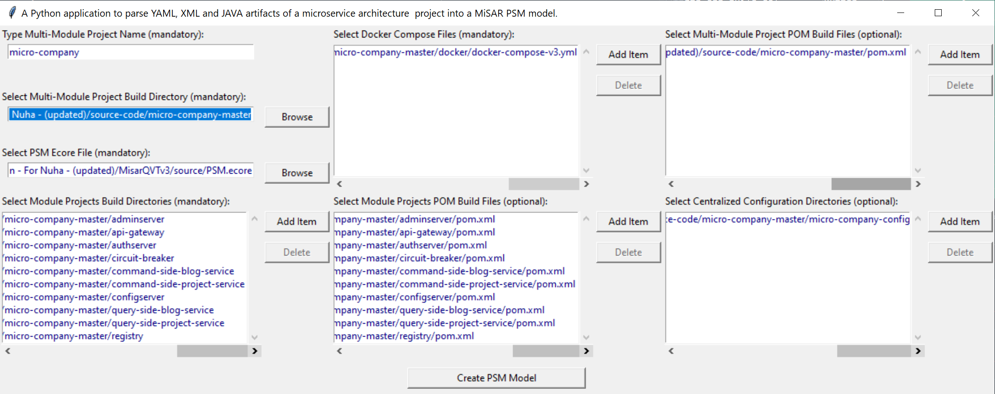

1. Make sure that you select the ***PSM Ecore File*** located at path ./***MiSARQVTv3/source/PSM.ecore***

inside the ***MiSARQVTv3*** eclipse project.

1. Also make sure that all mandatory fields are filled then click on ***Create PSM Model***
2. 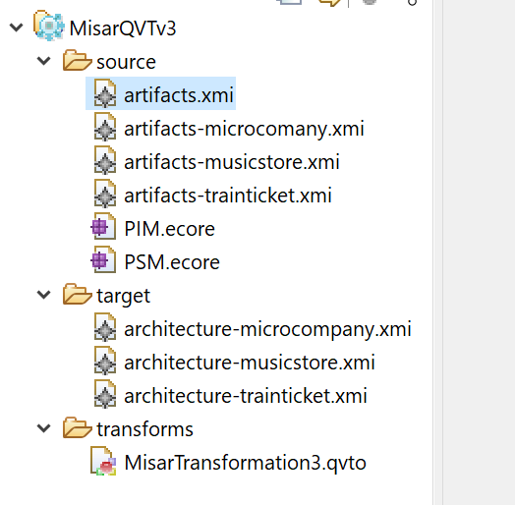When parsing is completed, the output PSM instance file ***artifacts.xmi*** will be saved automatically at path ./***MiSARQVTv3/source/artifacts.xmi***

inside the ***MiSARQVTv3*** eclipse project.

1. Right click on ***MiSARQVTv3*** project folder then click on ***Refresh***
2. To open the PSM instance file in tree-view, right click the ***artifacts.xmi*** file then ***Open With*** -> ***Sample Reflective Ecore Model Editor***

1. If the PSM instance file fails to open in tree-view, right click the ***artifacts.xmi*** file then ***Open With*** -> ***Text Editor***. At line 2, remove the following attribute inside <PSM:RootPSM> element:

xmlns:xsi="http://www.w3.org/2001/XMLSchema-instance"

Save and close ***artifacts.xmi*** file then repeat steps 9 and 10.

